# Alkem Smile Admin Functionalities Manual

## Table of Contents

1. Admin Functionalities
   * Activity Management
   * Event Management
   * Volunteer Management
   * Experience Moderation
   * Event Location Management
   * Gallery & Suggestions Management

## Admin Functionalities

### 1. Activity Management

* **Create/Edit Activities:** Admins can add new activities or edit existing ones, including name, type (annual/year-round), description, and certificate eligibility.
* **Rich Description Editor:** Use template builder or direct HTML for activity objectives, details, and FAQs.
* **Image Upload:** Attach images to activities for gallery display.
* **Status Update:** Activate/deactivate activities as needed.
* **Table View:** Search, filter, and edit activities from a responsive table.

**Flow:**   
1. Go to “Activities” (<https://www.alkemites.com/Smile/admin/activities>) in the admin sidebar.

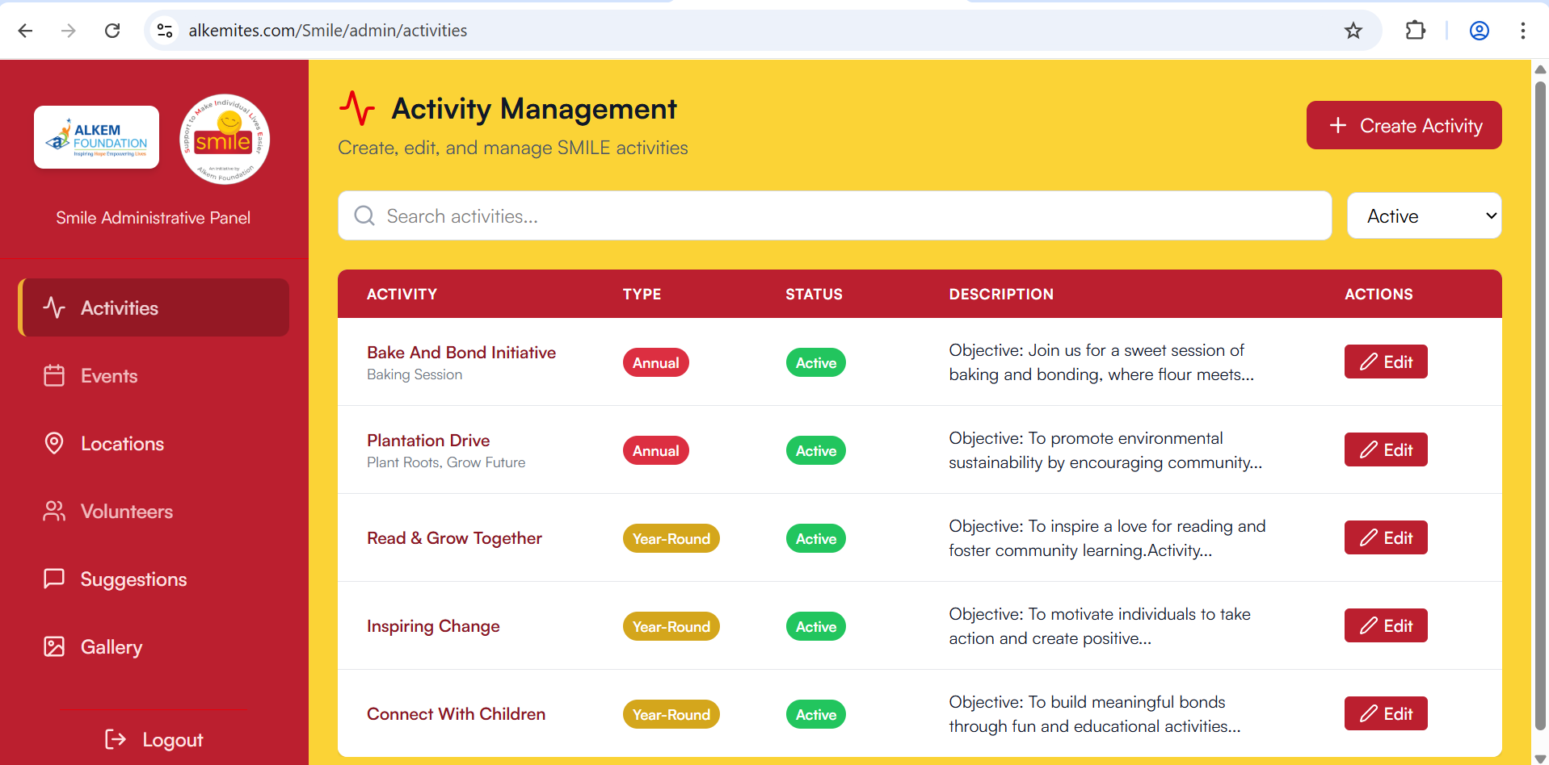

2. Click “Create Activity” to open the form.

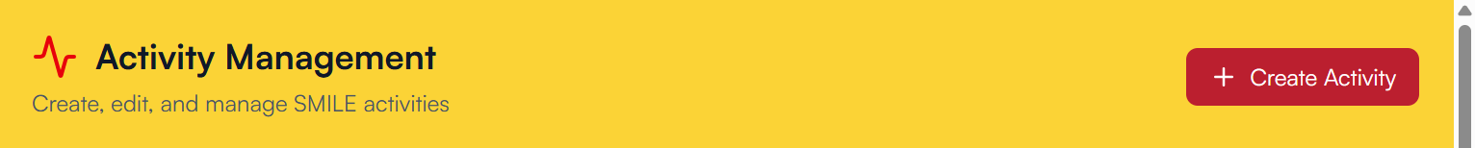

3. Fill in activity details, use the description helper if needed.

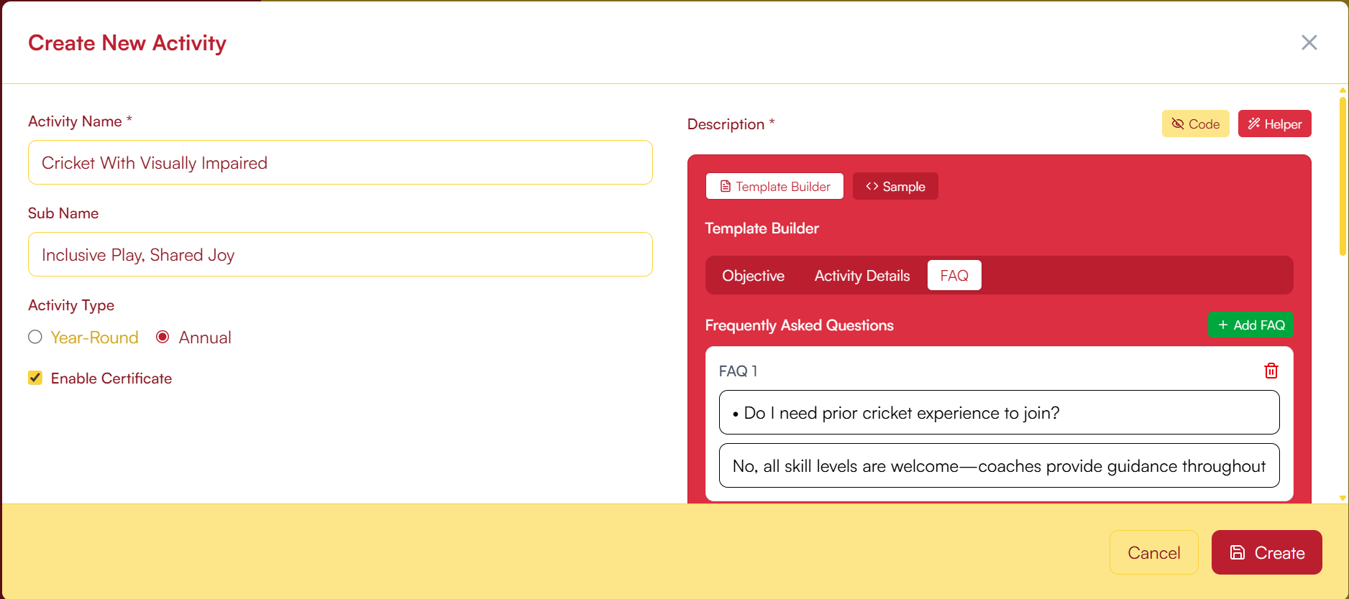

Using the template builder :

**a.** Click on the red helper button to open the builder  
 

**b.** Add the details as required using the “Objective”, “Activity Details”, “FAQ” as required, , “Activity Details”, “FAQ” use the greed “Add Line” and “Add FAQ” to add multiple entries

**Note :** A bullet “•” is by default added in the text boxes , only erase the bullet you do not want a bullet to appear in final look.

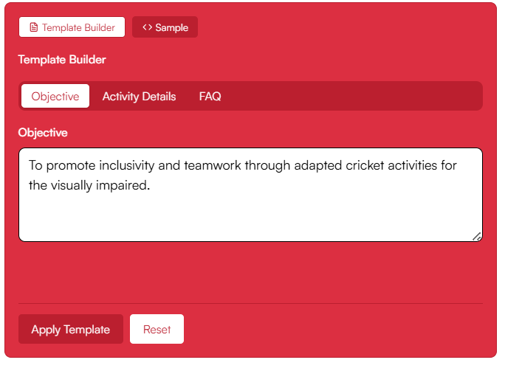

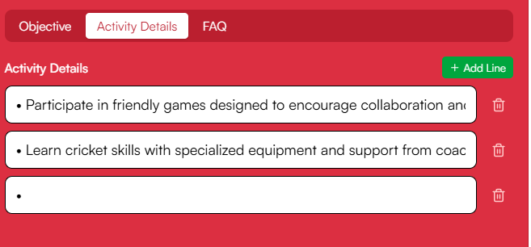

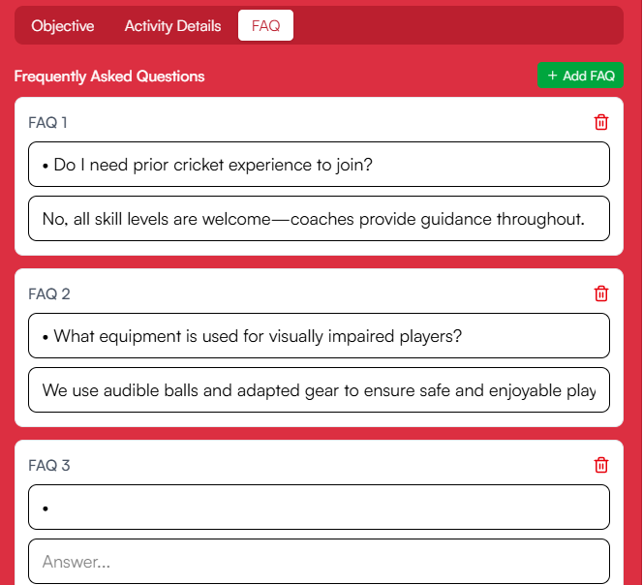

**c.** After clicking on apply template preview the output using the “code/preview” toggle  
 **Note:** The code view displays the HTML parse of the data inserted changes to that must only be made with prior knowledge of HTML syntaxes.



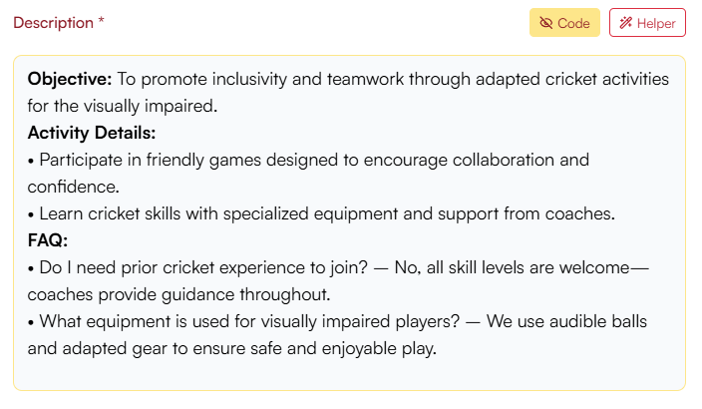



4. Click on Create to Save the Activity to the Database. Or Cancel to abort the creation of the Activity (by default status of Activity will be “Active”)

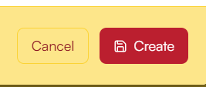

5. Use the table to search, filter, or edit activities. To add Image, Update status or details as required.  
  
 **a.** Search using the search bar at top and filter between “Active” and “Deactivated” dropdown in right.  


1. To **Add Image** / **Edit Details** / **Edit Status** click on the Edit button in the action’s column.

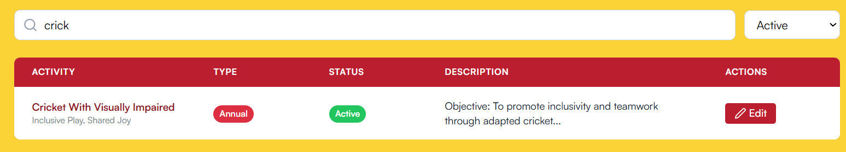

1. Here you can :
   1. Change The Status : (Active/Deactivated)  
       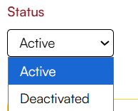
   2. Edit Name, Sub Name, Description (using the template builder or code)  
       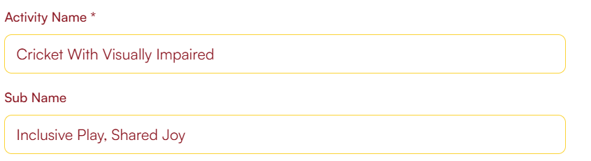  
      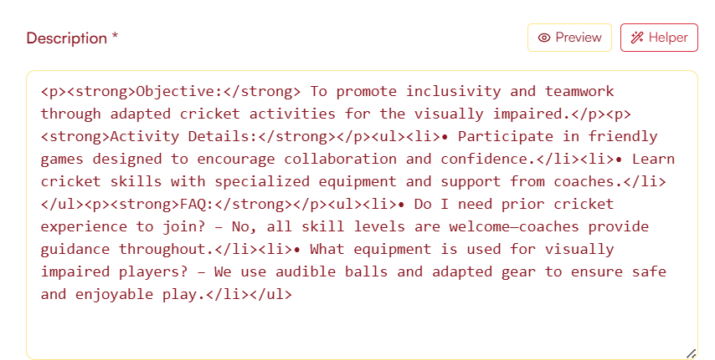
   3. Change Activity Type, or Enable Certificate Check box (Note : The text “synced” shows the current selection(Checked/Unchecked) is the current status of “Enable Certificate” )  
      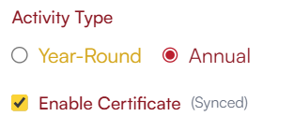
   4. **Uploading Image:  
       1.** Click on Update Image:  
       **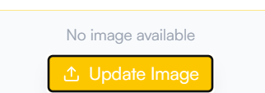  
        
      2.** Image picker of your system will open and choose an image for the same **3.** After the image is added its preview will appear on below, Use the save new image to upload the image to the database 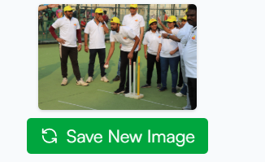 After successful upload a message box will be shown for confirmation  
      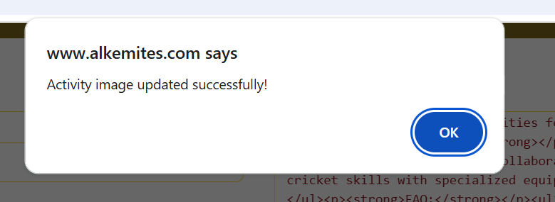  
      (**Note:** The image will be reflected only after updating / closing the popup and opening the same event details again)

**4.** Click on update to Send all the changes 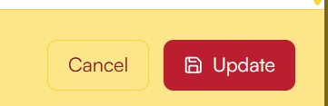

### 2. Event Management

* **Create/Edit Events:** Add new events with name, description, type, and assign activities.
* **Assign Locations & Dates:** Select one or more locations and set event dates/times.
* **Status Management:** Function to delete events.
* **Event Details:** View and edit event objectives, FAQs, and related activities.
* **Table View:** Search, filter by year, and manage events in a sortable table.

**Flow:**   
1. Navigate to “Events” (<https://www.alkemites.com/Smile/admin/events>) in the admin Sidebar.

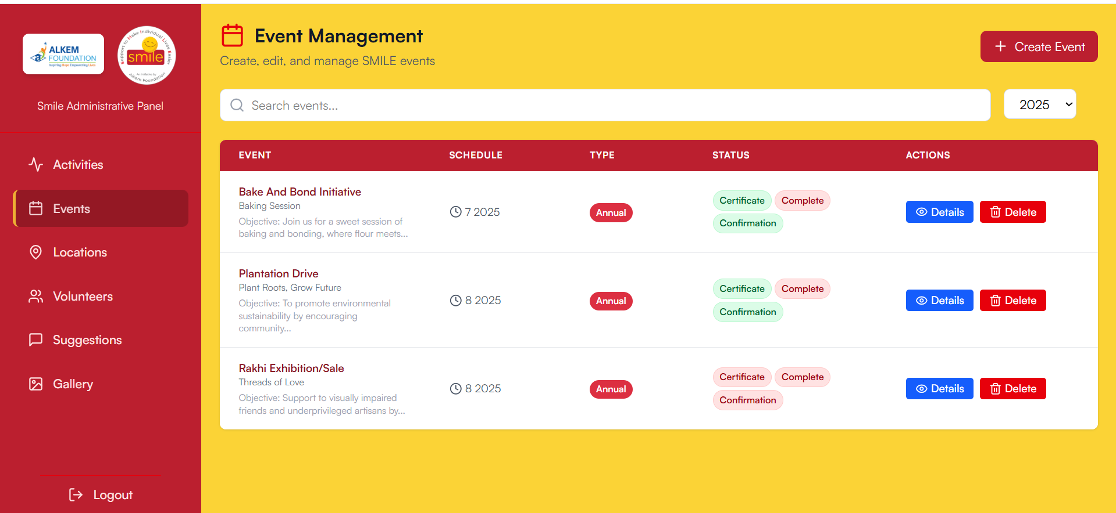

2. Click “Create Event” and fill in event details.



1. This will open the “Create New Event Popup”

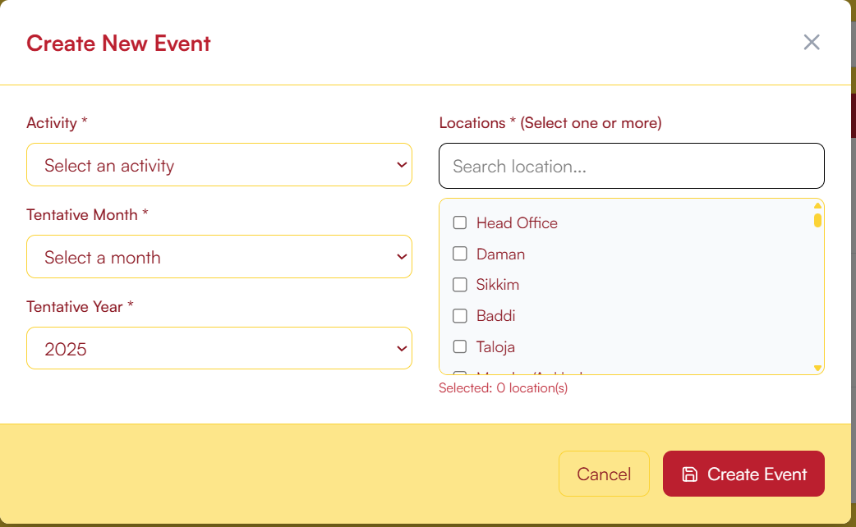

1. Select an Activity (Master List fetched from all the Activities created in Activity Page),   
     
   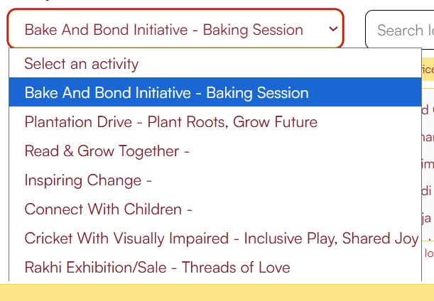  
     
   Choose a Tentative Month or Tentative Year using the respective dropdowns,   
   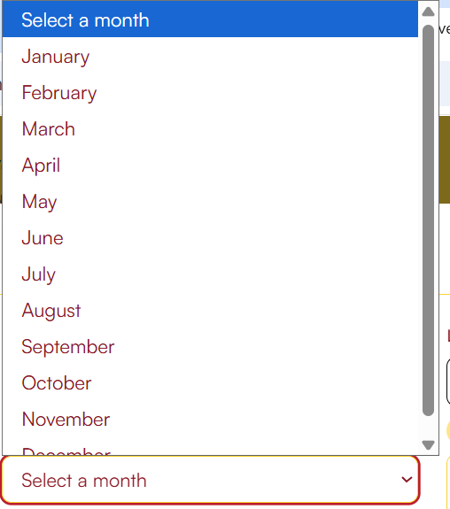 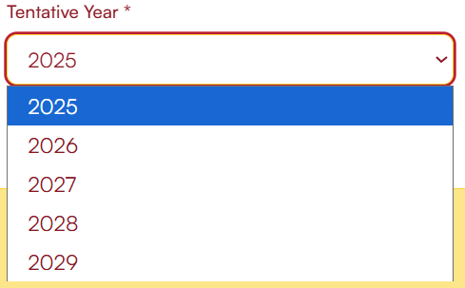  
     
   search or scroll through the list of locations all selected locations will be reflected in the form.   
   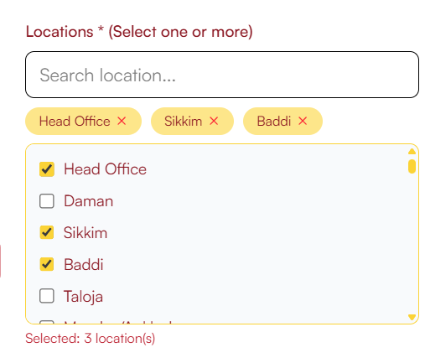
2. Click on “Create Event” to Confirm the event creation or cancel to abort the creation.  
   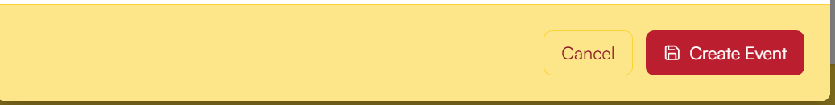

3. To Edit details, locations, time click on the “Details” button.

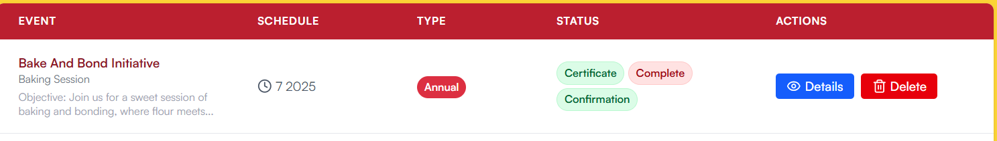

1. This will open a popup to view all the current details for event.
2. Navigate through “Event Details”, and “Locations” to change their details respectively
   * In “**Event Details”** you are able to change :  
     1. Tentative Year and Month Toggle  
        
     2. Nomination Confirmation (To Confirm the event)  
        (**Note:** Only toggle this after the event has been confirmed and all the location dates , time and venue details have been finalized)
     3. Event Complete (Toggle when the event is over)
     4. Certificate Access (Toggle when certificate is enabled)  
        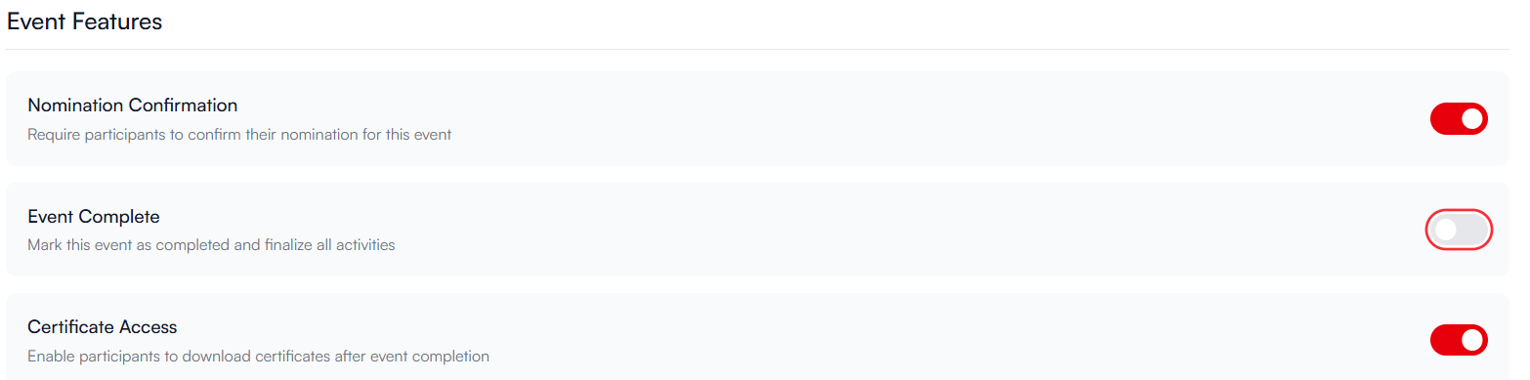
     5. If any changes is detected you will be prompted with the “Save Changes” or “Reset” buttons at the bottom of the popup  
          
        

* In **“Locations”** you are able to:
  1. View locations :  
     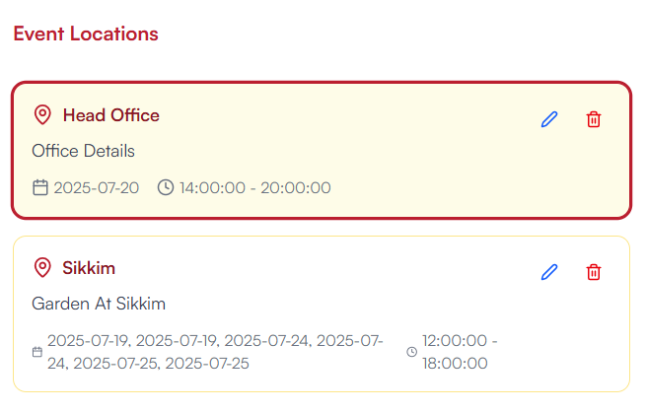
  2. Add Location fill in the data as required, select “Add” to create the Event Location   
     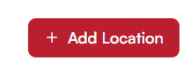  
     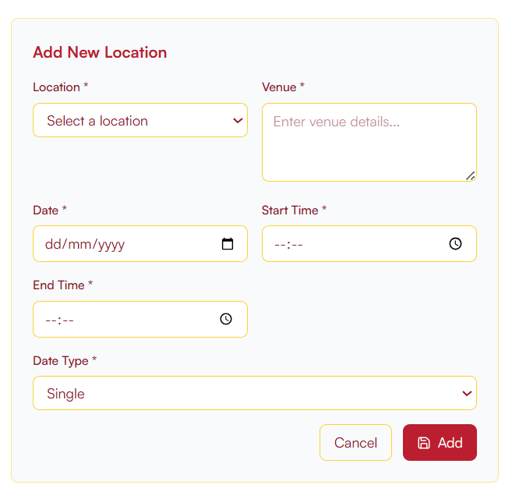
  3. Click on  to fetch the details in a form in the right side:  
       
     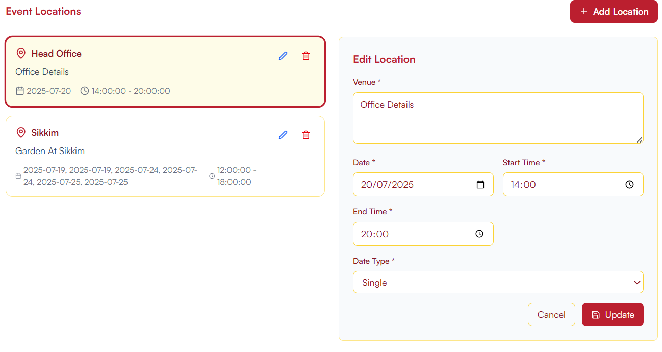
  4. Here you can edit the details
     + Venue Details  
       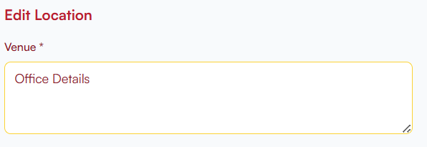
     + Date (Start Date) (click on calendar icon to select date)  
       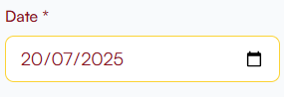
     + Start Time (click on Clock icon to select time)  
       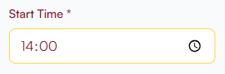
     + End Time (click on Clock icon to select time)  
         
       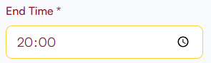
     + Date Type (Single, Multiple, Range), use selector as required   
       (**Note:** While Changing between date types you maybe prompted that on changing all current dates will be cleared. This will clear all dates of that current location only and new dates have to be added manually)  
       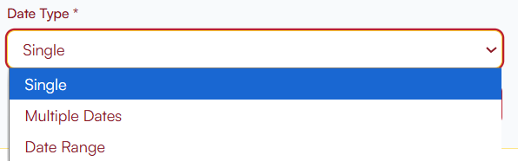  
         
       Multiple Dates:  
       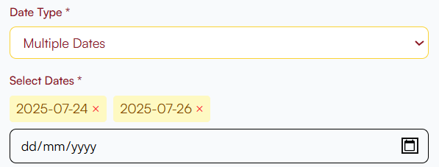  
         
       Date Range :  
         
       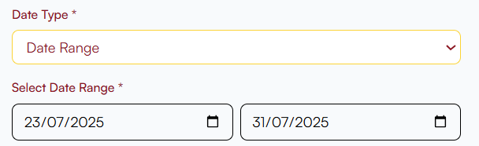
     + Click On “Update” to finalize the Updated data:  
       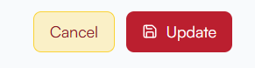

* 1. If you wish to delete an location simple use the delete icon to remove it.  
     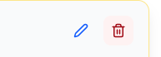  
     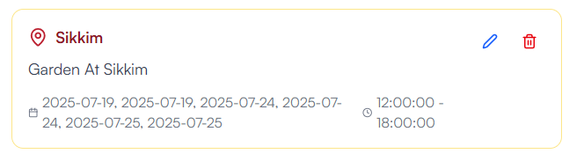

4. Save to add the event; manage events from the table.   
5. Edit, update status, or delete events as needed.

### 3. Volunteer Management

* **View Volunteers:** See all volunteers registered for events.
* **Status Update:** Mark as Attended / Not Attended volunteer statuses in bulk.

**Flow:**   
(**Note:** The search bar at top works for events and volunteers both depending on what section you are  
)   
  
1. Go to “Volunteers” (<https://www.alkemites.com/Smile/admin/volunteers>) page through the admin sidebar.   
2. Select an event to view its volunteers.

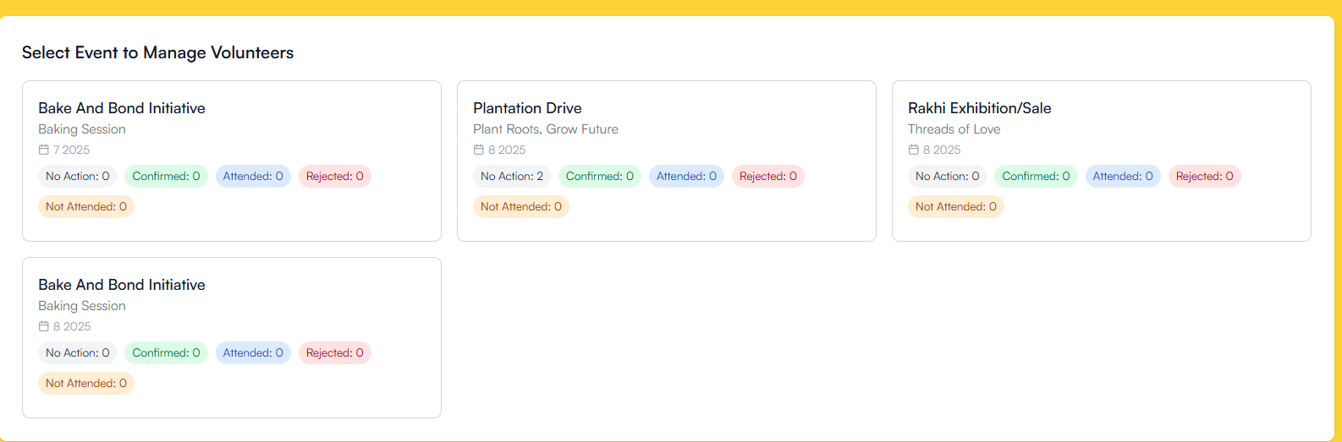

3. The Volunteer list, Status Summary, and the tables are displayed here  
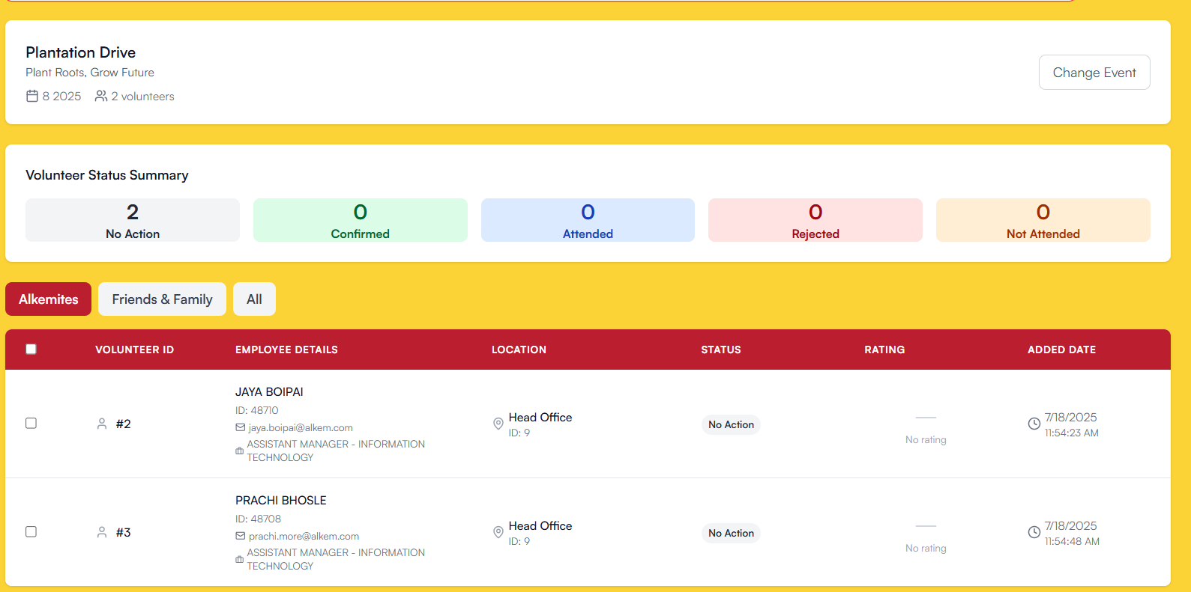  
**(Note:** You can use the “Change Event” button to select a different event )  
  
4. Use the Checkboxes in the left to bulk change status (Attended/Not attended of the Alkemite)

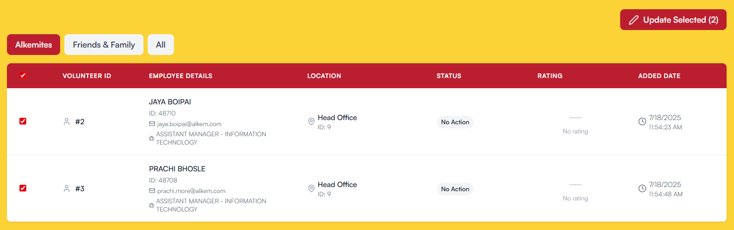

- Click on “Update Selected” button to open a popup to update the status. Select the status and then Click on “Update” or “Cancel” button as required.

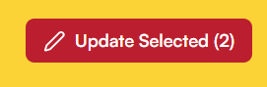  
  
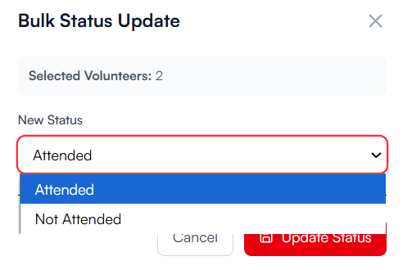  
  
  
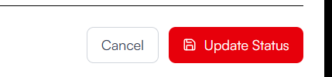

5. To export an excel sheet of the same use the “Export Nominations” button at the top to export sheet of the volunteer list of the selected event  


6. Similarly you can use Export button for the “Family & Friends” , and “All” tabs tables  
(Note : The “Export Nominations” button at top of the page will always export the Alkemites table)

### 4. Suggestions / Feedback / Experience Management

* **Review Experiences:** See all user-submitted experiences and suggestions.
* **Approve/Reject:** Moderate submissions; only approved experiences appear in the public gallery.
* **Detail View:** Read full submission details, including images and volunteer info.

**Flow:**   
(**Note:** The search bar at top works for events list and suggestion table both depending on what section you are  
)  
1. Open “Suggestions” (<https://www.alkemites.com/Smile/admin/suggestions>) from admin sidebar.   
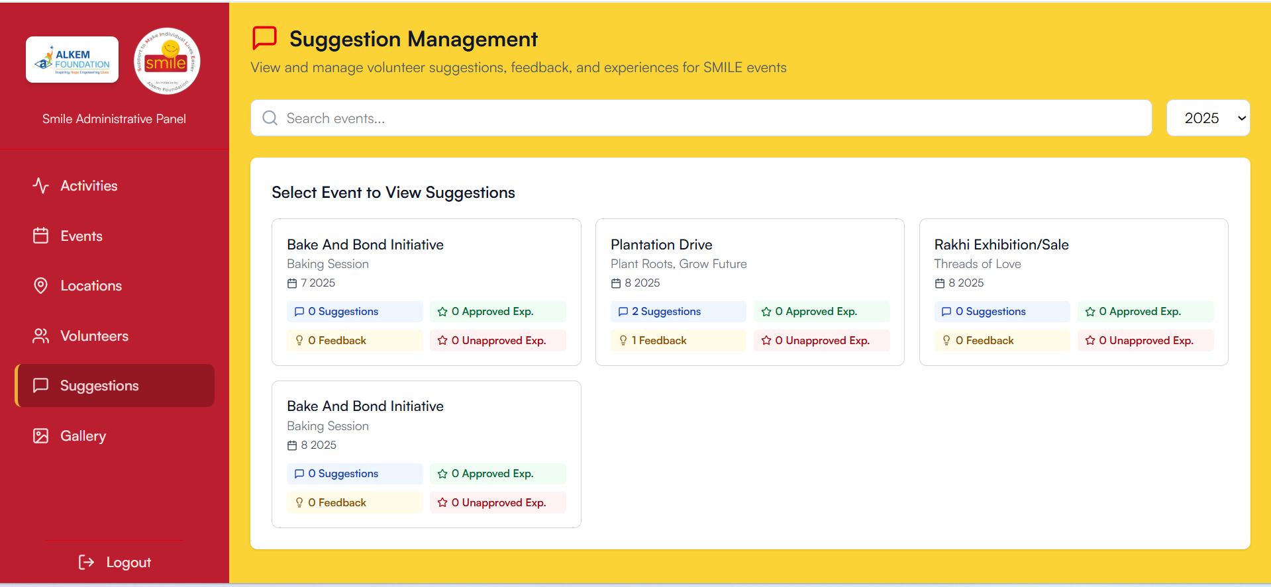

2. Select Event to view all types of suggestions (Suggestions, Experience , Feedback)   
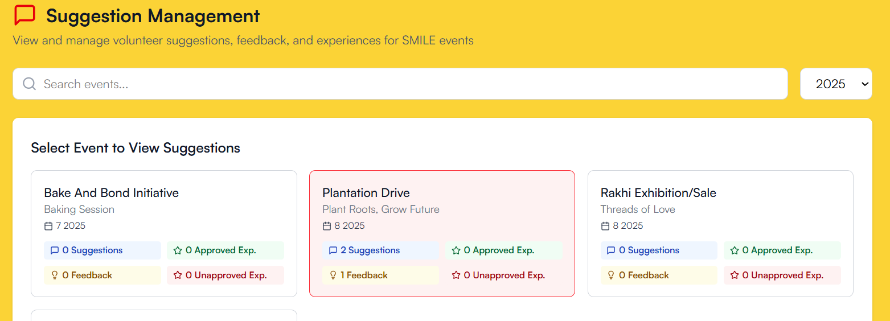  
  
  
3. Click to view details, then approve or reject.   
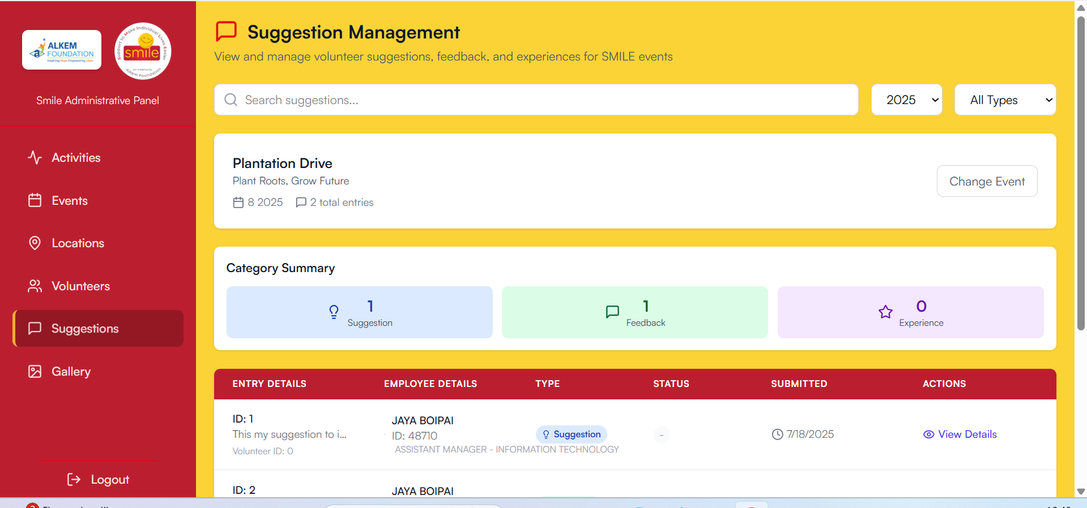  
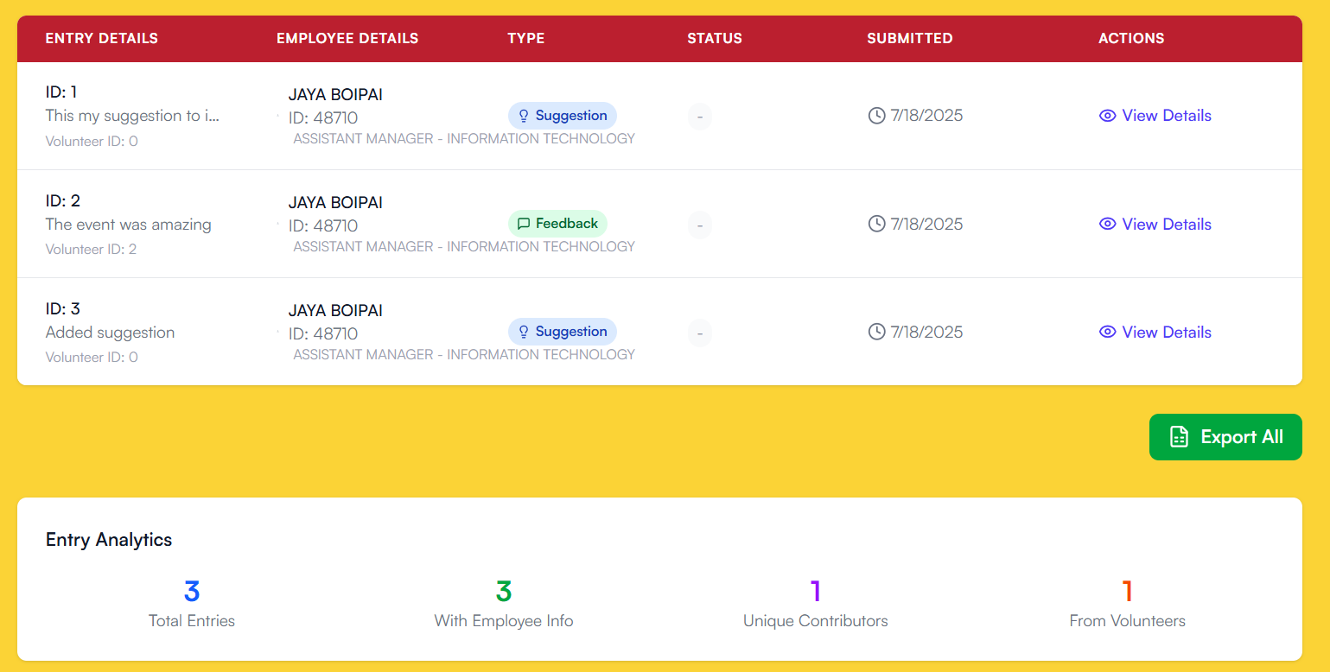  
  
  
4. You can filter suggestion as per needed (Suggestions, Feedback, Experience):  
  


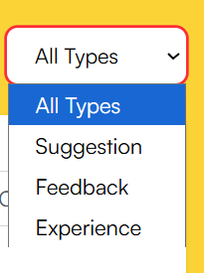  
  
5. Go to view Details to view all the details of the suggestion instance:  
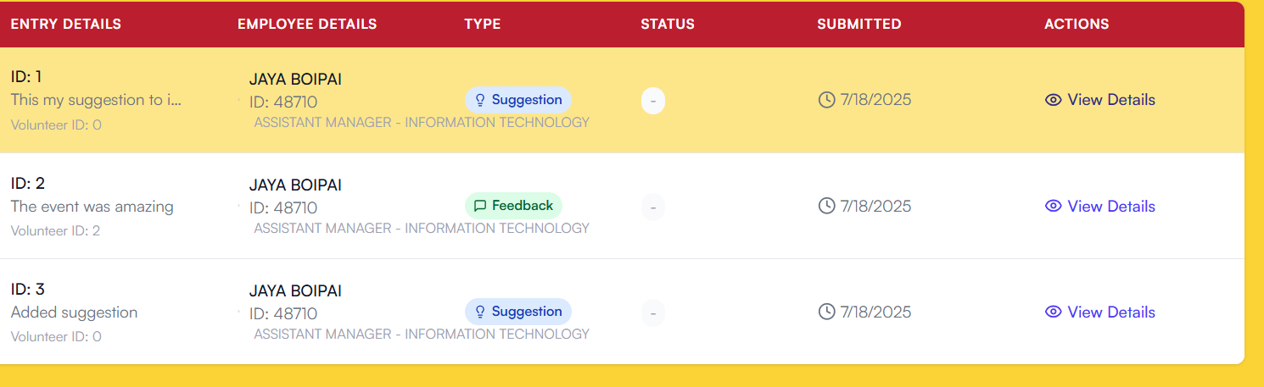  
  
  
  
5. For **Experience** moderation , click on an Experience View Details:  
  
  
 **a.** Here you can view all the details , image uploaded and change text of the experience if needed.  
 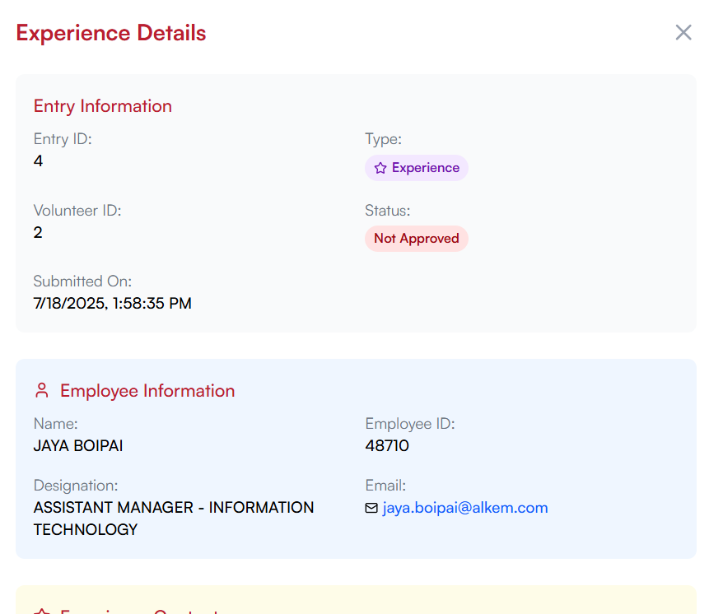  
  
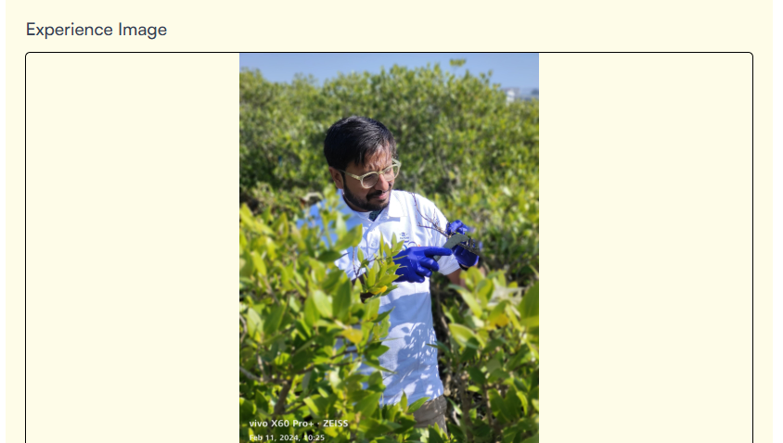 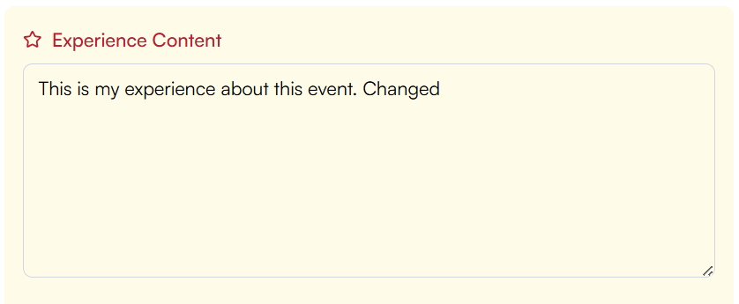  
  
   
 b. To change the status to (Approved / Unapproved) scroll to the bottom and click on the respective button.  
 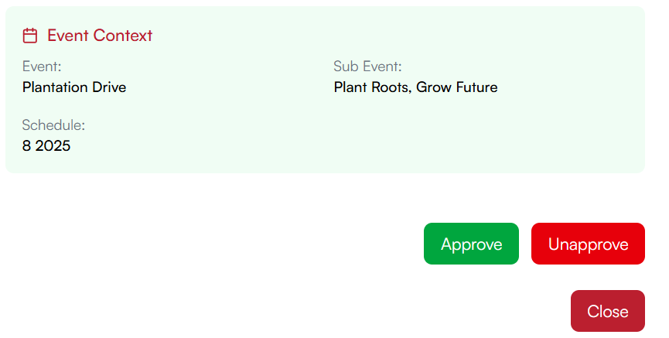  
  
(**Note :** The “Approve/Unapprove” button also functions as the update button , so if any text changes has been made to store it in the database click on these buttons itself as needed)

### 5. Gallery Management

* **Gallery Management:** Upload, deactivate images and videos in the Smile Gallery.
* **Tab View:** Switch between photo and video management.

**Flow:**   
1. Navigate to “Gallery” (https://www.alkemites.com/Smile/admin/gallery) from the admin sidebar.   
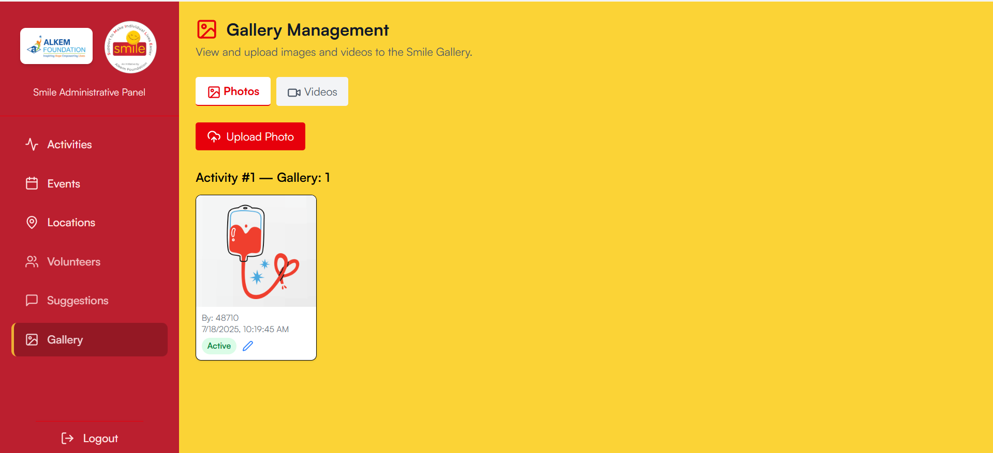

2. Use tabs to manage photos or videos.   
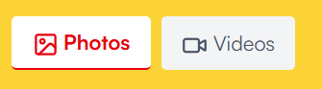  
  
3. Upload Photo / Upload Video to add photos or videos   
  
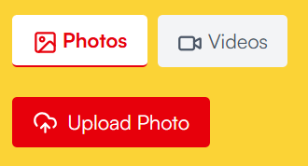  
  
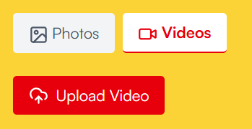  
  
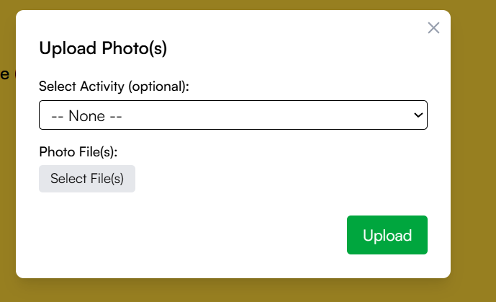  
  
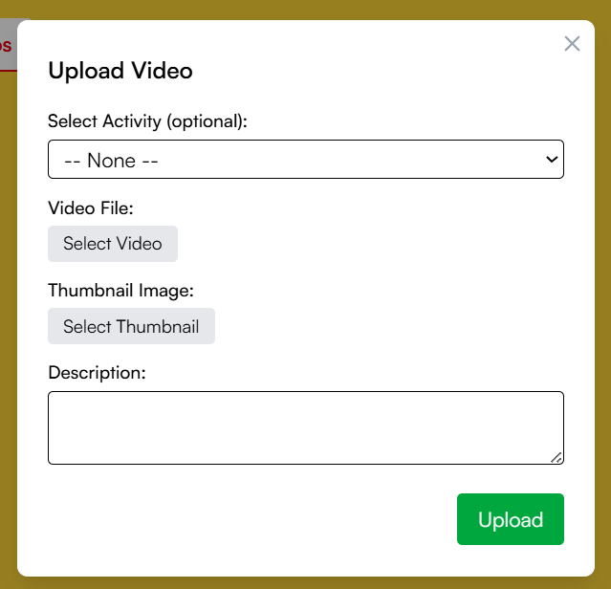  
  
(Note : The video upload also includes a “Select Thumbnail” which is the thumbnail photo, and description for the video)  
4. Click on pen icon to edit the status of the media  
  


 